|  |  |  |
| --- | --- | --- |
|  |  |  |
|  |  |  |
|  |  |  |

QUESTION 1

<!DOCTYPE html>

<html lang="en">

<head>

  <meta charset="UTF-8">

  <meta name="viewport" content="width=device-width, initial-scale=1.0">

  <title>CSS Grid Layout</title>

  <link rel="stylesheet" href="Q1.css">

</head>

<body>

<div class="grid-container">

  <div class="grid-item item1">1</div>

  <div class="grid-item item2">2</div>

  <div class="grid-item item3">3</div>

  <div class="grid-item item4">4</div>

  <div class="grid-item item5">5</div>

  <div class="grid-item item6">6</div>

  <div class="grid-item item7">7</div>

  <div class="grid-item item8">8</div>

  <div class="grid-item item9">9</div>

</div>

</body>

</html>

body {

    display: flex;

    justify-content: center;

    align-items: center;

    height: 100vh;

    background-color: #f4f4f4;

    margin: 0;

  }

  .grid-container {

    display: grid;

    grid-template-columns: repeat(3, 1fr);

    gap: 10px;

    width: 60vw;

  }

  .grid-item {

    display: flex;

    justify-content: center;

    align-items: center;

    font-size: 24px;

    font-weight: bold;

    color: white;

    padding: 20px;

  }

  /* Default Colors */

  .item1 { background: #00AEEF; }

  .item2 { background: #FF4500; }

  .item3 { background: #4169E1; }

  .item4 { background: #FFD700; }

  .item5 { background: #8A2BE2; }

  .item6 { background: #32CD32; }

  .item7 { background: #FF7F50; }

  .item8 { background: #20B2AA; }

  .item9 { background: #8B0000; }

  /* Media query to change colors when screen width is < 658px */

  @media (max-width: 658px) {

    .item1 { background: #ad1313; }

    .item2 { background: #e0cf2f; }

    .item3 { background: #cc217f; }

    .item4 { background: #10f510; }

    .item5 { background: #db9936; }

    .item6 { background: #f122b3; }

    .item7 { background: #0d90a1; }

    .item8 { background: #b7e708; }

    .item9 { background: #191cec; }

  }

OUTPUT OF QUESTION 1

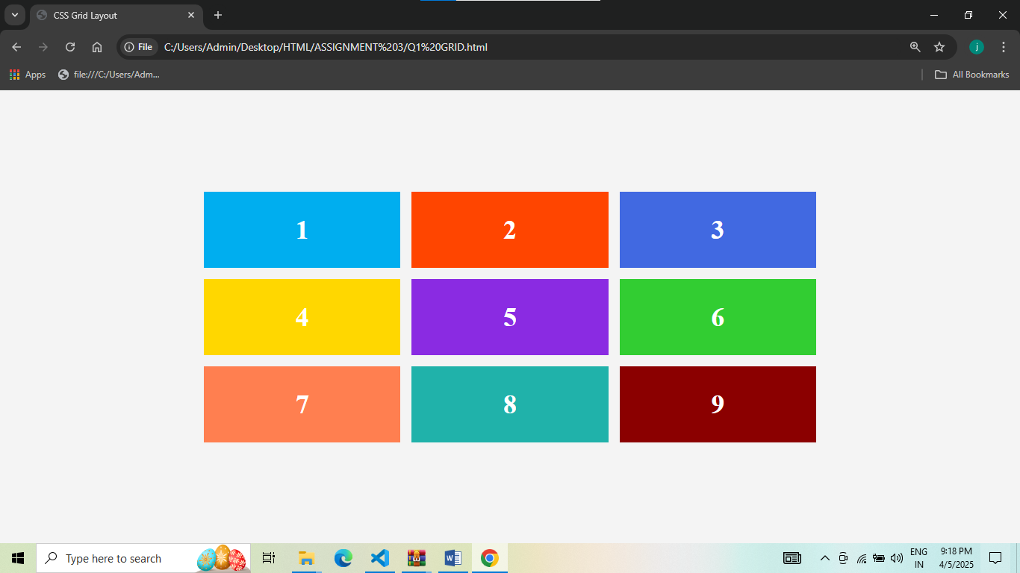

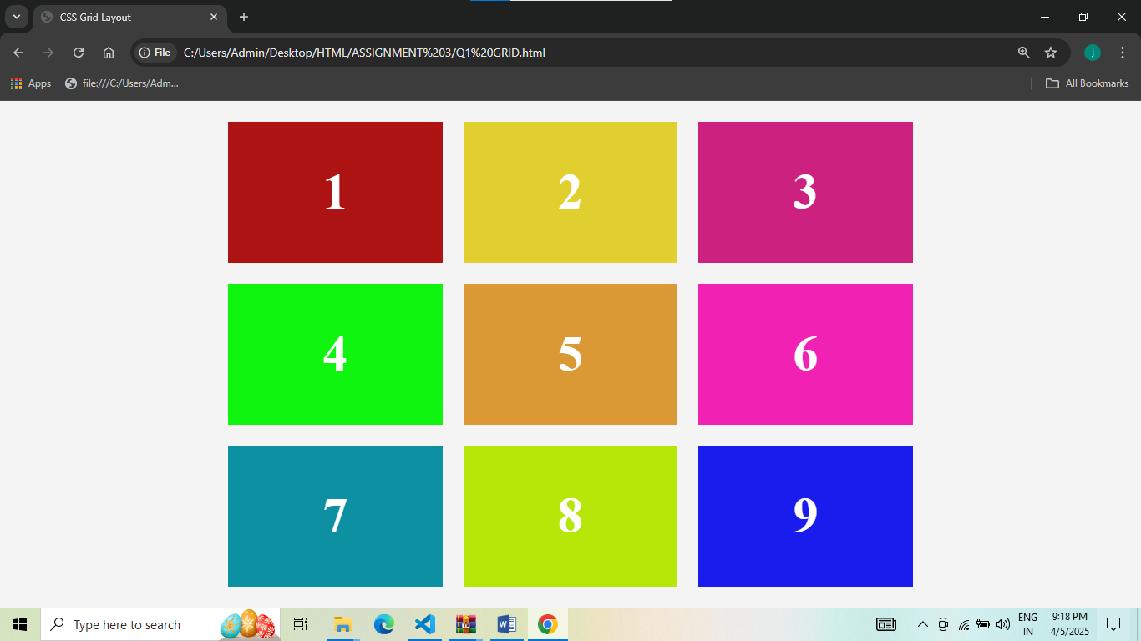

QUESTION 2

<!DOCTYPE html>

<html lang="en">

<head>

  <meta charset="UTF-8">

  <title>College Time Table</title>

  <style>

    body {

      font-family: Arial, sans-serif;

      text-align: center;

      margin: 30px;

    }

    h1 {

      font-size: 28px;

      margin-bottom: 20px;

      text-transform: uppercase;

    }

    table {

      width: 100%;

      border-collapse: collapse;

      margin: auto;

    }

    th, td {

      border: 1px solid #000;

      padding: 10px;

      text-align: center;

      vertical-align: middle;

    }

    th {

      background-color: #f0f0f0;

    }

  </style>

</head>

<body>

  <h1>COLLEGE TIME TABLE</h1>

  <table>

    <tr>

      <th></th>

      <th>8:30-9:30</th>

      <th>9:30-10:30</th>

      <th>10:30-11:30</th>

      <th>11:30-12:30</th>

      <th>12:30-2:00</th>

      <th>2:00-3:00</th>

      <th>3:00-4:00</th>

      <th>4:00-5:00</th>

    </tr>

    <tr>

      <td>MONDAY</td>

      <td>---</td>

      <td style="color: blue; font-weight: bold;">SUB1</td>

      <td style="color: orange; font-weight: bold;">SUB2</td>

      <td style="color: purple; font-weight: bold;">SUB3</td>

      <td rowspan="6" style="writing-mode: vertical-lr; font-weight: bold;">LUNCH</td>

      <td style="color: green; font-weight: bold;">SUB4</td>

      <td style="color: red; font-weight: bold;">SUB5</td>

      <td style="font-weight: bold;">COUNSELLING CLASS</td>

    </tr>

    <tr>

      <td>TUESDAY</td>

      <td style="color: blue; font-weight: bold;">SUB1</td>

      <td style="color: orange; font-weight: bold;">SUB2</td>

      <td style="color: purple; font-weight: bold;">SUB3</td>

      <td>---</td>

      <td style="color: orange; font-weight: bold;">SUB2</td>

      <td style="color: orange; font-weight: bold;">SUB2</td>

      <td style="color: gray; font-weight: bold;">LIBRARY</td>

    </tr>

    <tr>

      <td>WEDNESDAY</td>

      <td style="color: blue; font-weight: bold;">SUB1</td>

      <td style="color: orange; font-weight: bold;">SUB2</td>

      <td style="color: crimson; font-weight: bold;">SWA</td>

      <td>---</td>

      <td colspan="2" style="font-weight: bold;">LAB</td>

      <td></td>

    </tr>

    <tr>

      <td>THURSDAY</td>

      <td style="color: blue; font-weight: bold;">SUB1</td>

      <td style="color: orange; font-weight: bold;">SUB2</td>

      <td style="color: purple; font-weight: bold;">SUB3</td>

      <td>---</td>

      <td style="color: orange; font-weight: bold;">SUB2</td>

      <td style="color: orange; font-weight: bold;">SUB2</td>

      <td style="color: gray; font-weight: bold;">LIBRARY</td>

    </tr>

    <tr>

      <td>FRIDAY</td>

      <td style="color: blue; font-weight: bold;">SUB1</td>

      <td style="color: orange; font-weight: bold;">SUB2</td>

      <td style="color: purple; font-weight: bold;">SUB3</td>

      <td>---</td>

      <td style="color: green; font-weight: bold;">SUB4</td>

      <td style="color: red; font-weight: bold;">SUB5</td>

      <td style="color: gray; font-weight: bold;">LIBRARY</td>

    </tr>

    <tr>

      <td>SATURDAY</td>

      <td style="color: blue; font-weight: bold;">SUB1</td>

      <td colspan="3" style="font-weight: bold;">SEMINAR</td>

      <td style="color: green; font-weight: bold;">SUB4</td>

      <td style="color: red; font-weight: bold;">SUB5</td>

      <td style="color: gray; font-weight: bold;">LIBRARY</td>

    </tr>

  </table>

</body>

</html>

OUTPUT OF QUESTION 2

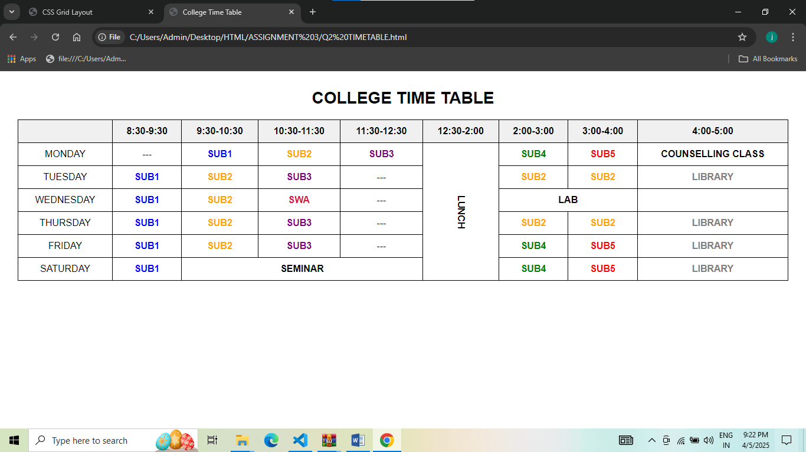

QUESTION 3

<!DOCTYPE html>

<html lang="en">

<head>

  <meta charset="UTF-8">

  <title>My TimeTable</title>

  <style>

    body {

      font-family: 'Georgia', serif;

      text-align: center;

      margin-top: 50px;

    }

    .title {

      font-size: 24px;

      font-weight: bold;

      margin-bottom: 20px;

    }

    table {

      margin: 0 auto;

      width: 600px;

    }

    th, td {

      border: 2px solid #000;

      padding: 10px;

      font-size: 18px;

    }

  </style>

</head>

<body>

  <h2 class="title">My TimeTable</h2>

  <table>

    <thead>

      <tr>

        <th rowspan="2">Day</th>

        <th colspan="2">Session</th>

      </tr>

      <tr>

        <th>Schedule</th>

        <th>Course Name</th>

      </tr>

    </thead>

    <tbody>

      <tr>

        <td>Sunday</td>

        <td>16:00 - 16:50</td>

        <td>Web Technology</td>

      </tr>

      <tr>

        <td>Sunday</td>

        <td>17:00 - 17:50</td>

        <td>Network Management</td>

      </tr>

      <tr>

        <td>Monday</td>

        <td>18:00 - 18:50</td>

        <td>IT Project Management</td>

      </tr>

    </tbody>

  </table>

</body>

</html>

OUTPUT OF QUESTION 3

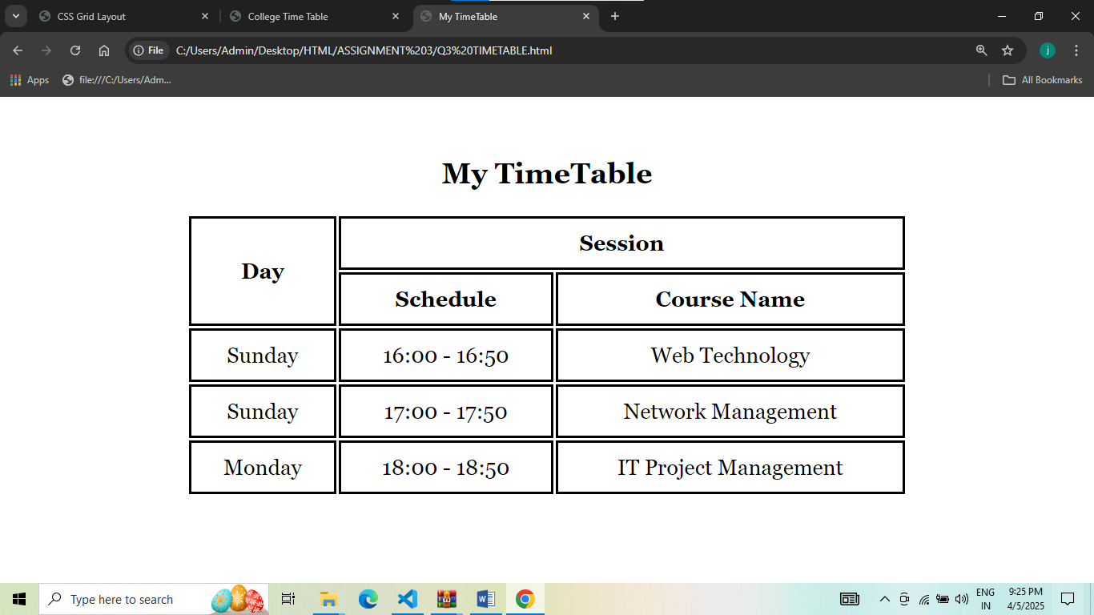

QUESTION 4

<!DOCTYPE html>

<html lang="en">

<head>

  <meta charset="UTF-8">

  <title>Center Box</title>

  <style>

    body {

      margin: 0;

      display: flex;

      justify-content: center;

      align-items: center;

      height: 100vh;

    }

    .box {

      width: 200px;

      height: 200px;

      background-color: #4da6ff;

      color: white;

      display: flex;

      justify-content: center;

      align-items: center;

      font-family: sans-serif;

      font-size: 1.2rem;

      border-radius: 10px;

    }

  </style>

</head>

<body>

  <div class="box">Centered Box Model</div>

</body>

</html>

OUTPUT OF QUESTION 4

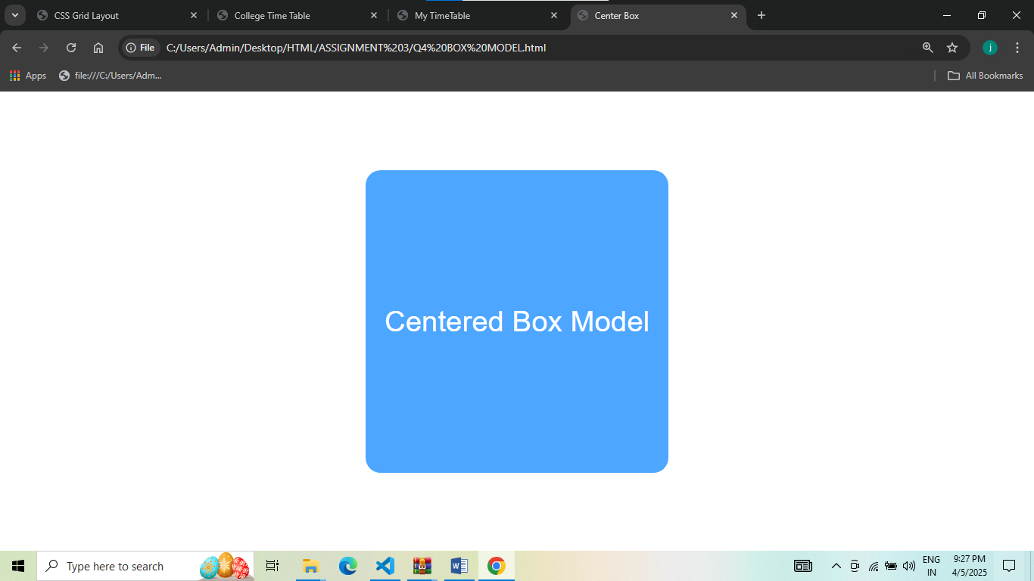

QUESTION 5

<!DOCTYPE html>

<html lang="en">

<head>

  <meta charset="UTF-8">

  <title>Responsive Navbar</title>

  <link rel="stylesheet" href="Q5.css">

</head>

<body>

  <nav>

    <a href="#">Home</a>

    <a href="#">About</a>

    <a href="#">Services</a>

    <a href="#">Contact</a>

  </nav>

</body>

</html>

* {

    margin: 0;

    padding: 0;

    box-sizing: border-box;

  }

  nav {

    background-color: #333;

    color: white;

    display: flex;

    justify-content: space-around;

    align-items: center;

    padding: 1rem;

    font-family: sans-serif;

  }

  nav a {

    color: white;

    text-decoration: none;

    font-size: 1rem;

  }

  @media (max-width: 600px) {

    nav {

      flex-direction: column;

      gap: 10px;

    }

  }

OUTPUT OF QUESTION 5

LAPTOP SCREEN SIZE

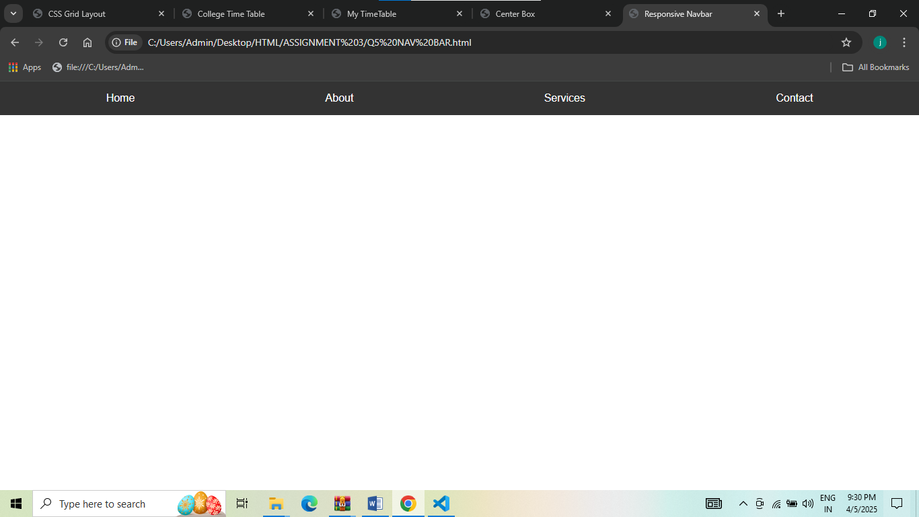

MOBILE SCREEN SIZE

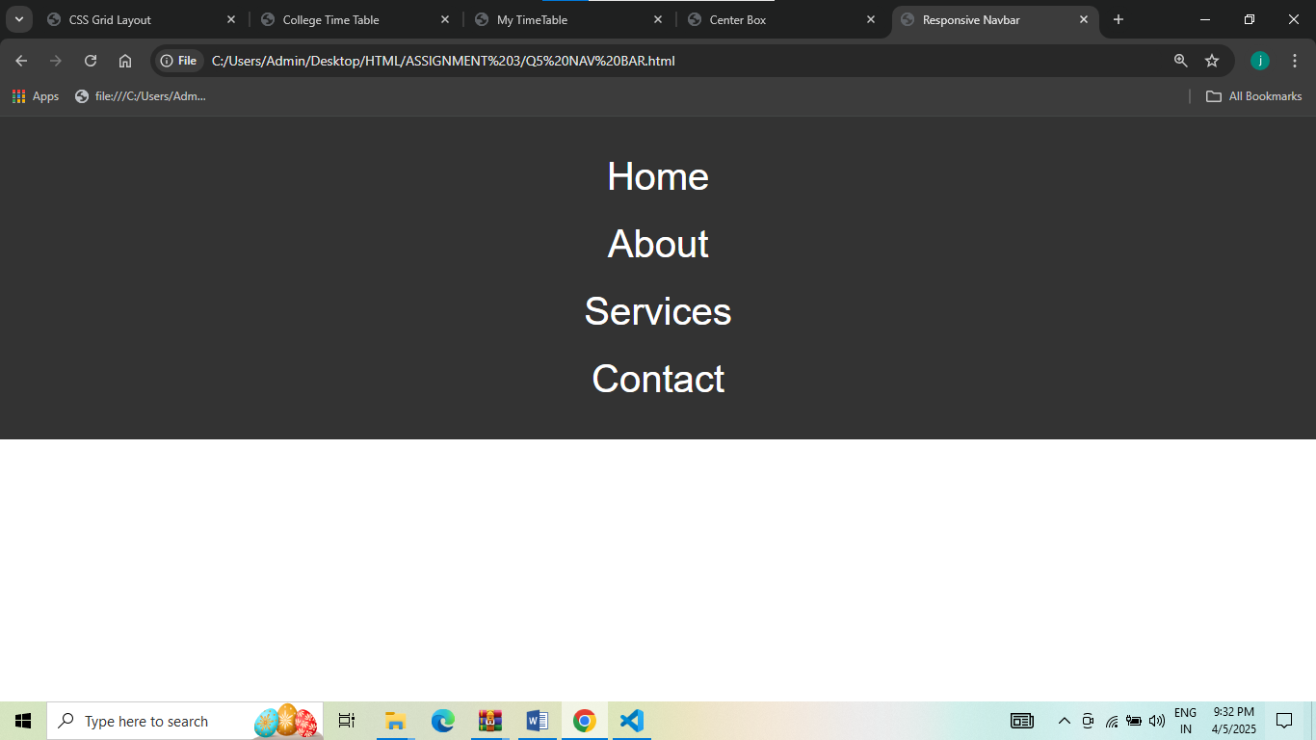

QUESTION 6

<!DOCTYPE html>

<html lang="en">

<head>

  <meta charset="UTF-8">

  <title>Responsive Cards</title>

  <link rel="stylesheet" href="CARDS.css">

</head>

<body>

  <section class="card-container">

    <div class="card">

      <img src="img1.png" alt="Nature Image">

      <h3>Nature Vibes</h3>

      <p>Relax and refresh with the beauty of nature all around you.</p>

    </div>

    <div class="card">

      <img src="img2.png" alt="Tech Image">

      <h3>Tech Trends</h3>

      <p>Stay ahead with the latest innovations in technology and design.</p>

    </div>

    <div class="card">

      <img src="img3.png" alt="Food Image">

      <h3>Delicious Bites</h3>

      <p>Explore tasty recipes and food ideas to spice up your meals.</p>

    </div>

  </section>

</body>

</html>

* {

    margin: 0;

    padding: 0;

    box-sizing: border-box;

  }

  body {

    font-family: sans-serif;

    padding: 20px;

    background-color: #f9f9f9;

  }

  .card-container {

    display: flex;

    gap: 20px;

    justify-content: center;

    flex-direction: row;

  }

  .card {

    background-color: white;

    border-radius: 10px;

    box-shadow: 0 4px 8px rgba(0, 0, 0, 0.1);

    overflow: hidden;

    width: 300px;

  }

  .card img {

    width: 100%;

    height: 50%;

  }

  .card h3 {

    padding: 15px 15px 5px;

    color: #333;

  }

  .card p {

    padding: 0 15px 15px;

    color: #666;

    font-size: 0.95rem;

  }

  /* Responsive behavior */

  @media (max-width: 768px) {

    .card-container {

      justify-content: center;

      flex-direction: column;

    }

  }

OUTPUT OF QUESTION 6

LAPTOP SCREEN SIZE

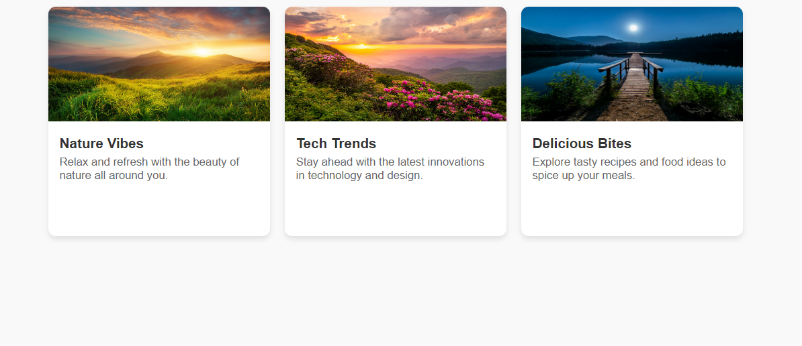

MOBILE SCREEN SIZE

